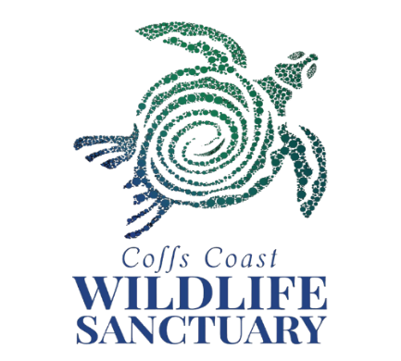

Application for Work Experience at Coffs Coast Wildlife Sanctuary

All future correspondence will use your email address, so please ensure the email address is clear, correct and regularly checked.

Participants Details

Name: _____________________________________________________________________ Mobile Phone: _______________________________________________________________

Email: _____________________________________________________________________

DOB:_____/_____/________

Careers Adviser Details

Careers Adviser Name: ________________________________________________________

Careers Adviser Email: _________________________________________________________

School Details

School Name: ________________________________________________________________

Suburb: _____________________________________________________________________

School Phone: ________________________________________________________________

Placement Date Options

It is very important that your school approves the dates you select – once placed you are unable to change your dates. (**Please also note we do not accept students for work experience during school holidays**) Please state 2 weeks that you are available. Our program runs **4** days - Monday to Thursday.

Week 1: From ______________ to ______________

OR

Week 2: From ______________ to ______________

Please tell us why you would like to do your work experience at Coffs Coast Wildlife Sanctuary and what you think you can contribute:

_________________________________________________________________________________

_________________________________________________________________________________

_________________________________________________________________________________

_________________________________________________________________________________

_________________________________________________________________________________

_________________________________________________________________________________

Tell us about how you or your family contribute towards conservation efforts, reducing waste and recycling:

_________________________________________________________________________________

_________________________________________________________________________________

_________________________________________________________________________________

_________________________________________________________________________________

I understand if I am successful with my application for work experience at Coffs Coast Wildlife Sanctuary, I will need to pay a fee of $55 on arrival to cover costs associated with my work experience. Signed:

Student: _____________________________________

Parent/Guardian: ______________________________

Please be aware that due to the popularity of our work experience program we may be fully booked up to 12 months in advance.

Email all applications to volunteers@ccws.org.au